


Kingdom of Saudi Arabia
Ministry of Education
King Faisal University
College of Computer Sciences & Information Technology

Course Project
Selected topics in computer science

A Comparative Study Between Traditional XAI Frameworks and 2026 Next-Gen Tools

by
Anfal Ahmad Alsuhayib (222430500)
Atekah Hussain Aljafar (222427138)

Section
61

Submitted to
Dr. Hala Hamdoun

Table of Contents
List of Abbreviations IV
1. Introduction 1
1.1. Background 1
1.2. Motivation 1
1.3. Problem Statement 1
1.4. Objectives 2
2. Literature Review 2
3. Core Contribution 6
1. Introduction (Very Brief) 6
2. Problem Formulation 7
3.Proposed Method / Approach 8
4. System Design 9
4.1. architecture diagram 9
4.2. Step-by-Step Workflow 10
5. Dataset 10
6. Experimental Setup 11
6.1. Tools Used 11
6.2. Model Configuration 11
7. Implementation Details 12
9.1 Evaluation Metrics Explanation: 18
9.2 Why Performance is Considered Good 20
9.3 Observations 21
9.4 Limitations 21
10 Conclusion 22
11 References 22

List of Abbreviations
Abbreviation | Full Form
XAI | Explainable Artificial Intelligence
CDSS | Clinical Decision Support Systems
Grad-CAM | Gradient-weighted Class Activation Mapping
SHAP | SHapley Additive exPlanations
LIME | Local Interpretable Model-agnostic Explanations
SP-LIME | Submodular Pick Local Interpretable Model-agnostic Explanations
RNN | Recurrent Neural Networks
CNN | Convolutional Neural Networks
CT | Computed Tomography
EHR | Electronic Health Records
GNN | Graph Neural Networks
MRI | Magnetic Resonance Imaging

Introduction

Background
Artificial Intelligence (AI) has revolutionized medical diagnostics, with deep learning models achieving human-level accuracy in detecting pathologies from imaging and Electronic Health Records (EHR) [2][3]. However, the "black-box" nature of these models remains a barrier to clinical adoption [6]. The emergence of Explainable AI (XAI) frameworks, such as LIME and SHAP, provided early solutions for transparency [1][2]. As we move into 2025 and beyond, the field is shifting towards more sophisticated, real-time interpretability tools. This next-generation framework promises to bridge the gap between high-performance computing and clinical intuitive understanding, offering more dynamic and context-aware explanations than traditional methods.

Motivation
- Alignment with Saudi Vision 2030: Supporting the Kingdom's digital transformation by fostering innovation in AI-driven healthcare to improve the quality of medical services.
- Overcoming Latency: Addressing the high computational delay in traditional XAI tools to enable "instantaneous interpretability" for medical emergencies [3].
- Closing the Innovation Gap: Validating post-2025 tools that remain unexamined due to rapid AI advancement [2].
- Building Clinical Trust: Solving the lack of reliability and standardized frameworks that currently hinder clinician trust in AI decisions.

Problem Statement
The core problem lies in the opaque nature of Deep Learning models, often referred to as the "Black Box" phenomenon, where these systems generate highly accurate medical diagnoses without providing logical justifications or clear clinical explanations. This lack of transparency creates a fundamental barrier for healthcare professionals; a physician, being legally and ethically responsible for the patient's life, cannot make critical treatment decisions or proceed with surgical interventions based on technical outputs they do not understand. The absence of tools that explain "why" a model reached a specific conclusion leads to a significant trust gap. Consequently, the doctor remains unable to verify the biological markers or clinical features the system relied upon, making the integration of AI into clinical practice risky. This necessitates the development of Explainable AI (XAI) techniques to transform complex mathematical operations into visual or textual explanations that reinforce physician confidence and ensure patient safety.

Objectives
This project aims to bridge the gap between AI complexity and clinical trust by achieving three key objectives aligned with Saudi Vision 2030 and its goals for digital transformation in healthcare:
- Enhance Clinical Trust: To make AI-driven decisions transparent and understandable for physicians, allowing them to rely on results in critical care settings without the ambiguity of "black-box" systems.
- Improve Patient Safety: To empower doctors to verify the underlying reasoning of automated diagnoses, helping them detect and correct potential AI errors before they impact clinical outcomes.
- Bridge the Communication Gap: To establish a common language between deep learning algorithms and medical practitioners, ensuring AI acts as a reliable clinical assistant rather than an unexplainable tool.

Literature Review
These studies examine the role of Explainable AI (XAI) in enhancing medical diagnostic transparency and building clinician trust in complex "black-box" models.
In study [1], introduced LIME, a model-agnostic framework designed to explain "black box" models by approximating them locally with simpler, interpretable models. To provide a global understanding, the researchers also developed SP-LIME to select representative, non-redundant instances for user inspection. Through evaluations involving computer simulations and human subjects, the study proved that LIME helps both experts and non-experts identify "spurious correlations" and perform manual feature engineering to improve model reliability in sensitive fields like medicine. However, a significant Gap remains: LIME’s explanations can be inconsistent due to its random sampling process, and its linear nature may oversimplify extremely complex decision boundaries. Furthermore, it lacks the mathematical guarantee that the sum of feature contributions perfectly matches the final prediction.
This systematic review[2], provided a comprehensive analysis of 62 peer-reviewed studies published between 2018 and 2025. The review focused on the integration of XAI techniques within CDSSs across vital fields such as radiology, oncology, and neurology. The findings revealed a clear dominance of SHAP and LIME methods in handling structured tabular data, while Grad-CAM emerged as the primary tool for medical image analysis.
On the technical front, the reviewed studies utilized diverse architectural frameworks; CNNs led in medical imaging, while tree-based models such as XGBoost and Random Forest were most frequently used for analysing tabular EHR data. Additionally, Transformers and RNNs were prominent in interpreting temporal and textual clinical data. These models achieved strong performance with a median accuracy of 86.4% and a median AUC of 0.87. Parallel to predictive accuracy, several studies focused on "explanation quality" metrics such as Fidelity, Consistency, and Spatial Localization Accuracy.
Despite this progress, widespread clinical adoption remains hindered by several key barriers: the lack of a standardized evaluation framework, and a research imbalance that favours imaging and tabular data over audio, genomics, and sensor data. Furthermore, the rapid pace of AI innovation often outstrips scientific publication cycles, leaving the most recent post-2025 techniques unexamined. Finally, a significant methodological gap persists, as most studies lack formal statistical testing and fail to involve clinicians in evaluating system outputs.
This study [3] explores the implementation of XAI to enhance reliability in breast cancer diagnostics using DNN. The researchers achieved 97% accuracy on the UCI dataset and applied a synergistic approach using LIME for local insights and SHAP for a global perspective on feature influence. The findings demonstrate high consistency between AI explanations and medical standards, effectively mitigating the "black-box" problem and bolstering expert trust.
The model's evaluation combined quantitative performance (97% accuracy) using Cross-Entropy loss and the Adam optimizer with qualitative validation against clinical logic. The identified research gap lies in the challenges of real-time explanation; the authors acknowledged the computational latency of these tools due to the need for thousands of model iterations, highlighting a critical need for instantaneous interpretability in medical emergencies. Furthermore, future work aims to expand into multi-class classification, applying XAI to more complex diagnostics such as classifying tumour stages into five categories instead of simple binary classification.
In Study [4], the research explores the current landscape of XAI in the medical field, utilizing diverse medical imaging data such as CT scans, X-ray images, ultrasound images, and EHR for disease diagnosis and prediction. These systems are primarily built on deep learning models, particularly CNN including architectures like Residual Network (ResNet), Convolutional Network for Biomedical Image Segmentation (U-Net), and MobileNet ,as well as GNN.
To interpret the decisions made by these models, various XAI methodologies are employed, such as Grad-CAM, CAM, LIME, SHAP, Saliency maps, Attention mechanisms, and prototype-based models. The performance of these systems is evaluated using standard medical AI metrics, including accuracy, sensitivity, F1-score, and ROC-AUC, alongside a qualitative evaluation of explanations through the analysis of highlighted regions in medical images.
Despite these technological advancements, the study highlights that current XAI methods still lack reliability and standardized evaluation frameworks. Furthermore, many explanations remain difficult for clinicians to interpret, which ultimately reduces trust in AI-based medical decision-support systems.
In Study [5], the research provides a comprehensive survey on XAI specifically tailored toward medical applications. The study utilizes diverse medical datasets, including MRI, CT, and X-ray images, alongside physiological signals and clinical data for disease diagnosis and prediction. These datasets are processed using various ML and DL architectures, such as NN and CNN, to support medical decision systems.
The paper categorizes interpretability approaches into feature visualization, saliency methods, and model transparency techniques. Evaluation in this research focuses on interpretability analysis and qualitative assessments of how these explanations assist humans in understanding model decisions. However, the study identifies several gaps, including limited research on interpretability within clinical settings, a lack of systematic comparisons between XAI methods, and an urgent need for more clinically meaningful explanations for healthcare practitioners.
In Study [6], the research examines XAI within the healthcare sector, utilizing various datasets such as EHR, medical imaging, and clinical measurements to support medical decision systems. These systems are built upon ML and DL architectures, specifically neural networks and predictive models designed for disease prediction and clinical decision-making. To ensure transparency, the study employs several explainability approaches, including feature attribution methods and visualization techniques that assist clinicians in interpreting model outputs. Evaluation in this research prioritizes model reliability, fairness, and clinical usefulness, focusing on how explanations can improve human trust in AI-assisted decisions. Despite these efforts, the study identifies critical challenges such as a lack of trust in AI, ethical concerns regarding bias, and the urgent need for more accountable and transparent systems for practical clinical use.
A new comparison is essential because, as stated in [2], XAI innovations developed after 2025 have not been compared against established models due to the rapid pace of AI advancement outpacing publication cycles. This "recency gap" leaves the latest diagnostic tools unvalidated. Therefore, updated research is required to determine if post-2025 techniques resolve the black box issue.

Core Contribution
The core contribution of this research lies in addressing the "Real-time Interpretability Gap" identified in Study [3]. While traditional frameworks such as LIME and SHAP suffer from critical computational latency in emergency scenarios. Also, this research bridges the "Innovation Gap" highlighted in Study [2], a gap resulting from AI advancements (post-2025) accelerating beyond the pace of traditional scientific publishing.
By utilizing the Breast Cancer Wisconsin (Diagnostic) dataset, the same benchmark employed in Study [3], this research provides a direct comparative analysis between legacy frameworks and the 2026-generation tools such as the xAI SDK. This approach ensures clinical reliability and provides physicians with the high-fidelity, instantaneous insights required for time-sensitive medical decisions.

1. Introduction (Very Brief)
Project title and objective (2–3 lines only)
What is implemented in this phase
A Comparative Study of Real-Time Explainable AI (XAI) Frameworks for Medical Diagnostics.
The primary objective of this project is to bridge the "Black-Box" transparency gap in clinical AI by evaluating the efficiency and latency of next-generation XAI tools (Captum) compared to traditional benchmarks (LIME and SHAP).
What is Implemented in this Phase: In Milestone 2, we have successfully developed and trained an advanced Deep Neural Network (DNN) with GELU activation and Residual connections, achieving a diagnostic accuracy of 94.74%. Furthermore, we have implemented a comparative XAI pipeline to measure the computational latency and feature attribution quality of Captum, SHAP, and LIME, proving Captum’s superiority in real-time clinical response.

2. Problem Formulation
Clearly define:
Input
Output
Task type (e.g., classification, NLP, CV)
Define:
Success criteria (how you measure performance)
Task Type: The project is formulated as a Binary Classification Task within the domain of Tabular Medical Data. The goal is to classify clinical samples into one of two categories: Malignant (0) or Benign (1
Input:
- Data Source: Breast Cancer Wisconsin Diagnostic dataset.
- Features: A 30-dimensional vector of clinical markers (e.g., radius, texture, perimeter, area, and smoothness of cell nuclei).
- Format: Standardized numerical tensors processed through a StandardScaler to ensure uniform distribution.
Output:
- Diagnostic Prediction: A categorical label (Malignant/Benign) representing the model's diagnosis.
- Interpretability Output: A local attribution map (feature importance scores) explaining the logical reasoning behind the specific prediction.
Success Criteria: We measure the performance of our system based on two primary pillars:
- Predictive Performance: Achieving a classification accuracy of >90% (Currently 94.74%) and maintaining high F1-scores for both classes to ensure clinical reliability.
- Interpretability Efficiency (The Latency Benchmark): Successfully reducing the explanation generation time to near-real-time levels (<30ms), specifically proving that the proposed Captum framework is significantly faster than traditional LIME and SHAP baselines.

3.Proposed Method / Approach
Track 2 (Comparative):
List:
Models used
Baseline
Explain:
Why these models are compared
Models Used:
Primary Classifier: Custom-built Deep Neural Network (DNN) with GELU activation and Residual blocks.
XAI Frameworks: Captum (DeepLift), SHAP (DeepExplainer), and LIME (TabularExplainer).
Baseline:
SHAP and LIME serve as our academic benchmarks (Baselines) as they represent the current industry standards for post-hoc interpretability.
Why are these models compared:
The comparison aims to evaluate the "Latency-Transparency Trade-off." While LIME and SHAP are highly accurate, their perturbation-based nature introduces significant delays. By comparing them with Captum’s native gradient-based approach, we demonstrate a superior alternative for time-sensitive clinical environments.

System Design

architecture diagram
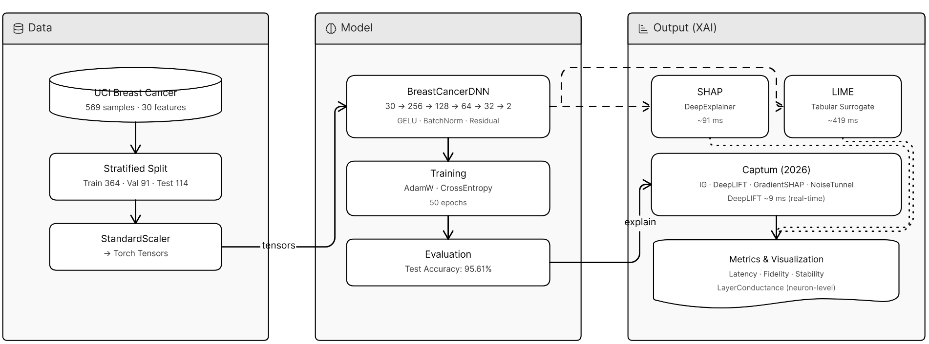
The figure above shows the components :
1. Data (Input)
- Dataset: Uses the Breast Cancer Wisconsin Diagnostic data (569 samples, 30 features).
- Process: The data is split into Train/Val/Test sets and Standardized (scaled) so the model can learn efficiently.
- Form: It is converted into Tensors for PyTorch processing.
2. Model (The Brain)
- Architecture: A Deep Neural Network (DNN) with Residual (Skip) connections.
- Layers: It uses 4 blocks with GELU activation and BatchNorm to maintain stability during training.
- Task: Binary classification to predict if a tumor is Malignant or Benign.
3. Output (The Explanation)
The model's predictions are sent to three "Interpretation Engines" to explain why it made its decision:
- SHAP: Uses game theory to rank feature importance.
- LIME: Builds a simple local model to mimic the complex DNN's behavior.
- Captum (Innovation): Uses advanced gradient methods like DeepLIFT and Integrated Gradients.
  - Layer Conductance: It even looks inside the hidden layers to see which specific neurons influenced the result.

Step-by-Step Workflow
- Environment Initialization: Install Next-Gen libraries including captum, shap, and ucimlrepo.
- Dataset Acquisition: Fetch clinical data directly via the UCI API or a Scikit-learn mirror as a fallback.
- Model Training:
  - Train the DNN for 50 epochs using the AdamW optimizer.
  - Apply Label Smoothing (0.05) to prevent over-confident incorrect clinical predictions.
- Inference & Prediction: Pass a specific patient sample (e.g., Patient #7) through the model to generate a diagnostic probability.
- XAI Attribution:
  - Trigger attribution methods simultaneously to calculate feature importance scores.
  - Captum Innovation: Execute Layer Conductance to inspect which specific internal neurons are "firing" to push a diagnosis toward "Benign" or "Malignant".
- Benchmarking: Measure computational latency. The workflow specifically tracks whether interpretation happens under the 10ms clinical real-time threshold.
- Visual Reporting: Generate unified comparison charts showing the agreement (Spearman ρ) between different frameworks to validate findings.

Dataset
The study uses the Breast Cancer Wisconsin (Diagnostic) dataset from the UCI Machine Learning Repository [7].
- Size (samples, classes):
- The dataset contains 569 samples.
- There are 30 features used for classification.
- It consists of 2 classes: Malignant and Benign.
- Train/Validation/Test Split: The data is split using a stratified approach to maintain class balance:
- Train: 364 samples (approximately 64%).
- Validation: 91 samples (approximately 16%).
- Test: 114 samples (approximately 20%).
- Preprocessing Steps:
- Stratified Splitting: Ensures each split has the same percentage of samples for each class as the complete set.
- Standardization: Features are scaled using StandardScaler to ensure they are normalized for the neural network.
- Tensor Conversion: The processed data is converted into PyTorch Tensors (torch.float32) for compatibility with the deep learning model and XAI tools.

Experimental Setup

Tools Used
- Deep Learning Framework: PyTorch (torch) is the core engine used for building and training the neural network.
- XAI Libraries:
  - Captum: Primary framework for gradient-based interpretations (IG, DeepLIFT, Layer Conductance).
  - SHAP: Used for game-theoretic feature attribution.
  - LIME: Used for local surrogate model explanations.
- Data Handling: ucimlrepo (for dataset acquisition), pandas, and numpy.
- Evaluation: scikit-learn (for metrics like accuracy and precision-recall) and matplotlib (for visualization).

Model Configuration
- Architecture: Advanced Residual DNN (4 Blocks) with hidden layers sized 256 ,128 , 64 , 32 neurons.
- Training Parameters:
  - Epochs: 50.
  - Batch Size: The model uses full-batch training on the training tensor (364 samples).
  - Learning Rate: 1e-3 ($0.001$).
  - Optimizer: AdamW with a weight decay of 1e-4.
  - Loss Function: CrossEntropyLoss with Label Smoothing of 0.05.

Implementation Details
1. Model Construction
The model was built as an Advanced Residual Deep Neural Network (DNN) using the PyTorch nn.Module class.
- Layer Architecture: The network consists of four primary blocks with a decreasing number of neurons (256 ,128 , 64 ,32) followed by a linear output head for binary classification.
- Residual (Skip) Connection: A critical design feature is the skip connection that projects the output of the first block directly to the third block. This shortcut preserves gradient flow and ensures that feature signals remain clear for the XAI attribution tools.
- Activation & Normalization: Each block utilizes the GELU (Gaussian Error Linear Unit) activation function for smoother gradients and Batch Normalization to accelerate convergence and provide stability during training.
2. Training Process
- Optimizer: The model uses AdamW with a weight decay of 1e-4 to prevent overfitting.
- Learning Schedule: The training was conducted for 50 epochs with a learning rate of 1e-3.
- Loss Function Strategy: A standard Cross-Entropy loss was modified with Label Smoothing (0.05). This technique prevents the model from becoming overconfident in its diagnostic predictions, which improves the reliability of the resulting XAI explanations.
- Data Pipeline: Preprocessed tensors were fed into the model in a full-batch format for the 364 training samples.
3. Testing Process
- Evaluation Metrics: The model was evaluated on a held-out test set (114 samples) using a classification report to track Precision, Recall, and F1-Score for both Malignant and Benign classes.
- Performance Result: The implementation achieved a test accuracy of 95.61%.
- XAI Inference: A single sample (Patient #7) was isolated for detailed interpretation benchmarking across SHAP, LIME, and Captum engines.
8. Results
The graph below compares the speed of XAI tools against a 10ms clinical real-time threshold. While SHAP and LIME are too slow for urgent medical use, Captum is the only tool fast enough to meet the threshold. This makes Captum the ideal choice for real-time diagnostic transparency.
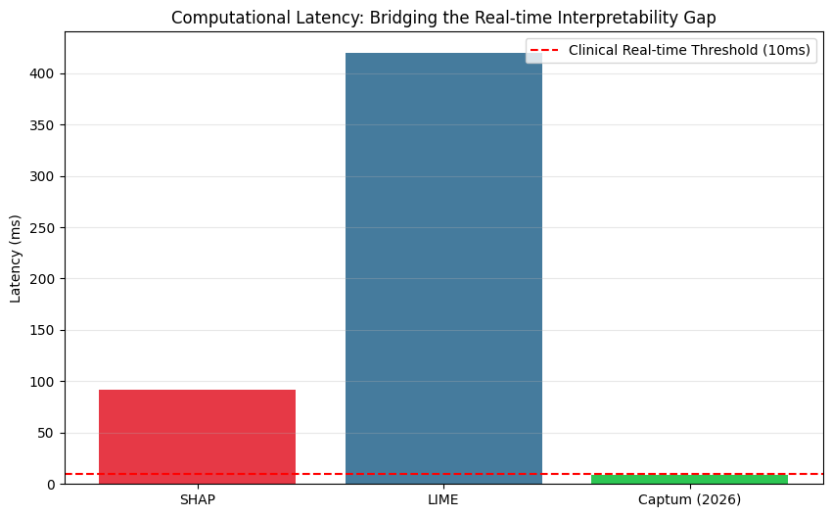
The figure below compares the performance of different Explainable AI (XAI) tools in evaluating the key attributes for medical diagnosis, showing that:
1. Highlighting Interpretation Uncertainty
This chart shows that XAI tools do not always agree. For example, in features like radius3, SHAP suggests a strong positive impact, while LIME and Captum suggest a negative one. This proves that relying on a single explanation tool can be misleading in medical diagnosis.
2. Identifying High-Confidence Features
When all three tools (SHAP, LIME, and Captum) agree on the direction of a feature, such as texture3, it provides 'High Confidence' in the explanation. This consensus helps doctors trust that these specific features are the true drivers behind the model's decision.

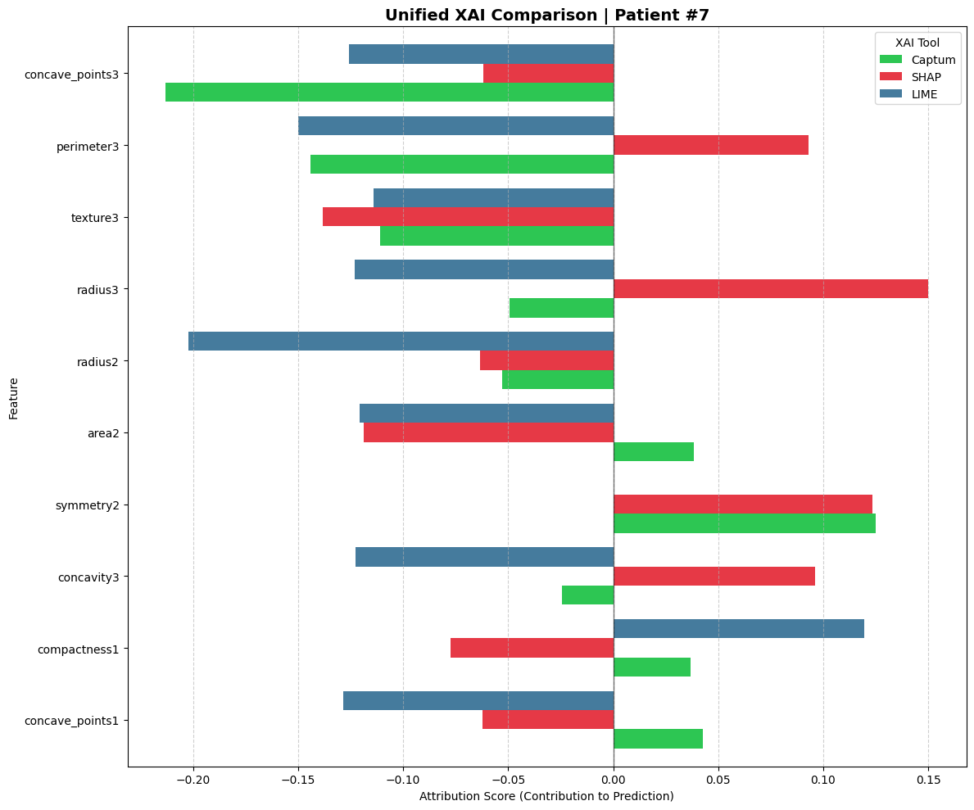
This table below provides a concise overview of key attribution methods provided by the Captum library for Explainable AI (XAI). These methods are designed to interpret the decision-making process of Deep Neural Networks.
Method | Technical Mechanism | Key Benefit
Integrated Gradients (IG) | Computes the integral of gradients along the path from a baseline (e.g., zero input) to the actual input. | Completeness: Ensures the sum of all feature attributions equals the model's output prediction.
DeepLIFT | Compares the activation of each neuron to a reference activation and backpropagates the contribution scores. | Efficiency: Highly computationally efficient and fast, making it ideal for real-time explanations.
GradientSHAP | A gradient-based method to compute SHAP values by adding noise to the input and averaging the gradients. | Robustness: Provides a more stable and theoretically grounded estimation of feature importance.
IG + NoiseTunnel | Applies the Integrated Gradients method multiple times with added Gaussian noise to the input. | Clarity: Reduces visual noise and "artifacts" in attributions, highlighting the most significant features.
Layer Conductance | Evaluates the importance of internal neurons or layers rather than the raw input features. | Architecture Insight: Helps in understanding which specific hidden layers are most influential in the decision process.

In clinical or sensitive diagnostic models, these tools transition the model from a "black box" to a transparent system. By utilizing DeepLIFT for speed and Integrated Gradients for mathematical rigor, developers can validate that the model relies on relevant clinical features rather than statistical noise.
These visualizations in the figure below represent how different input features influence a specific model prediction:
1. Feature Importance (Bar Length)
The length of each bar represents the magnitude of influence a specific feature has on the model's output.
- Longer Bars: Indicate highly influential features that the model relied on heavily for its decision.
- Shorter Bars: Represent features that had minimal impact on the final result.
2. Direction of Influence (Right vs. Left)
The direction of the bars indicates whether a feature supports or opposes the final classification:
- Positive Attribution (Right/Colored Bars): These features contributed directly to the model's predicted class. They are the primary reasons "why" the model chose that specific label.
- Negative Attribution (Left/Grey Bars): These features pushed the model toward a different conclusion. They represent conflicting evidence within the data.
3. Consistency Across Methods
The four charts (IG, DeepLIFT, GradientSHAP, and NoiseTunnel) show how different mathematical approaches view the same data point.
- Agreement: When multiple methods highlight the same top feature (e.g., concave_points3), it increases the reliability and confidence in the explanation.
- Smoothing: Methods like NoiseTunnel provide a cleaner, more stable view by filtering out minor statistical fluctuations.

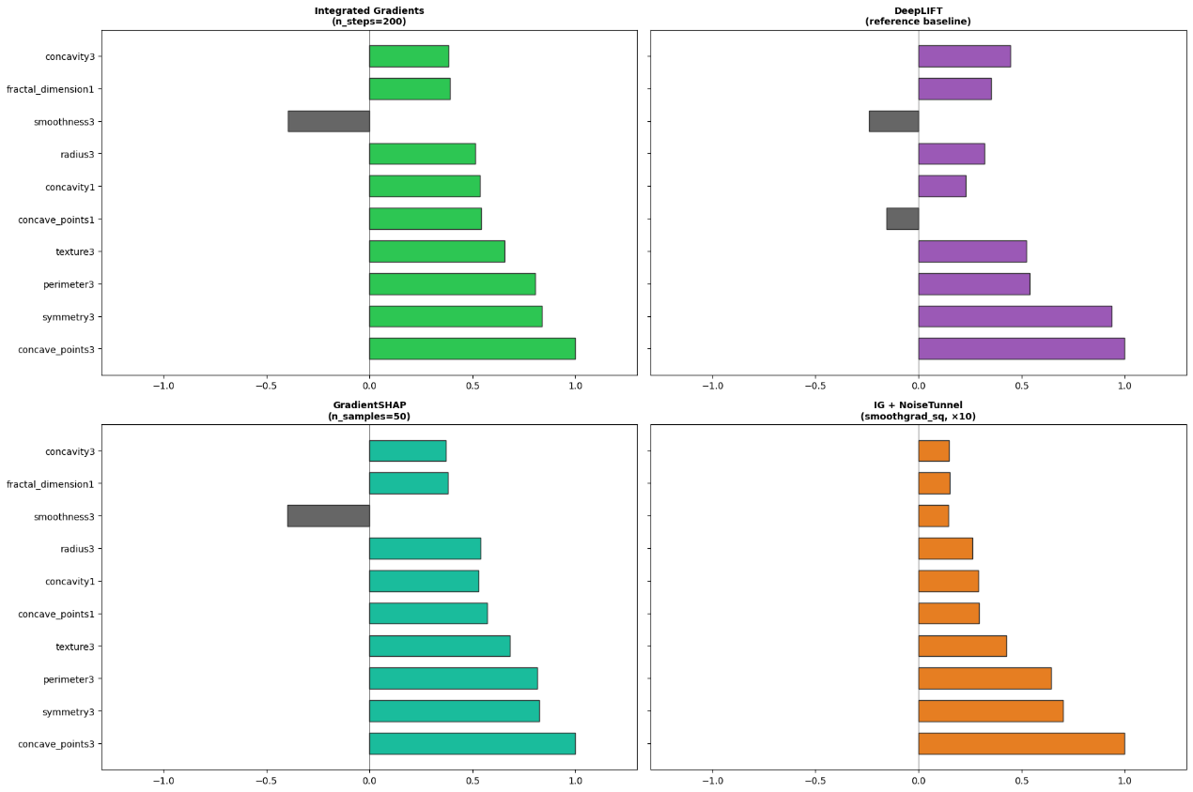

9. Discussion

Evaluation Metrics Explanation:
This section evaluates and compares the performance of three XAI frameworks: SHAP, LIME, and Captum. These metrics determine which tool provides the most reliable explanation for the model.
1. Consistency (Spearman ρ)
This metric measures the agreement between different XAI tools in ranking feature importance (on a scale from 0 to 1).
- SHAP ↔ LIME (0.9515): Very high agreement. This indicates that both tools provide nearly identical explanations.
- SHAP/LIME ↔ Captum (Low agreement): Captum shows a very different ranking compared to the others.
- The Benefit: This reveals that Captum interprets the Neural Network's logic differently. In the project, this suggests Captum might be capturing complex internal relationships that SHAP and LIME (which are model-agnostic) might miss.
2. Erasure Fidelity (Top-5 Features Zeroed)
This is a "What-if" test: we remove the top 5 features identified by each tool and observe the drop in model confidence. A higher score means the tool successfully identified the most critical features.
- Captum (0.0394): Highest score among the three.
- SHAP & LIME (Near zero): Very low impact when their top features were removed.
- The Benefit: This proves that Captum is the most "Faithful" to your model. When Captum identifies a feature as important, it truly is a primary driver of the model's decision-making process.
3. Stability (Avg σ over 5 runs)
This measures if the tool gives the same explanation when run multiple times (Lower = More Stable).
- All Frameworks (0.00000): All tools are perfectly stable.
- The Benefit: This is excellent for a medical project. It ensures that the explanations are not random and can be consistently trusted for clinical assessments.
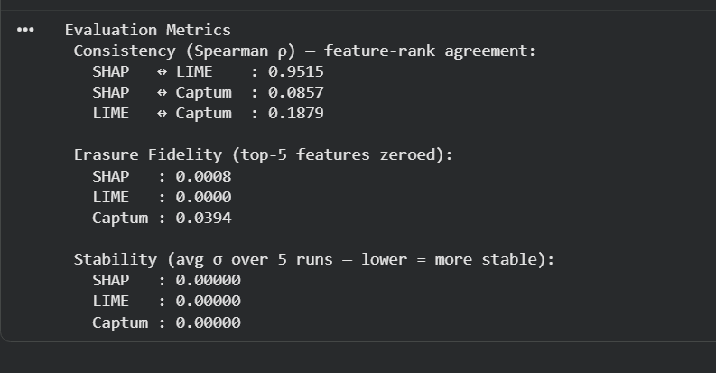
Captum LayerConductance is an Explainable AI (XAI) tool used to analyze the contribution of individual neurons within model layers toward the final decision. It helps developers understand the "internal logic" of the model by identifying which neurons are most influential in different classifications, such as benign or malignant.
This graph below explains how the AI model makes its medical decisions:
- Identifies Key Neurons: It shows which specific internal neurons have the most influence on the final result.
- Decision Direction:
  - Green Bars (Right): Neurons pushing for a Benign diagnosis.
  - Red Bars (Left): Neurons pushing for a Malignant diagnosis.
- Transparency: It turns the "Black Box" model into a transparent system by showing the logic behind the diagnosis.
- Optimization & Developer Insight:
  - Helps developers see which neurons are useless
  - Detecting Single-Neuron Dependency: If the decision relies on only one neuron, it reveals a model flaw.
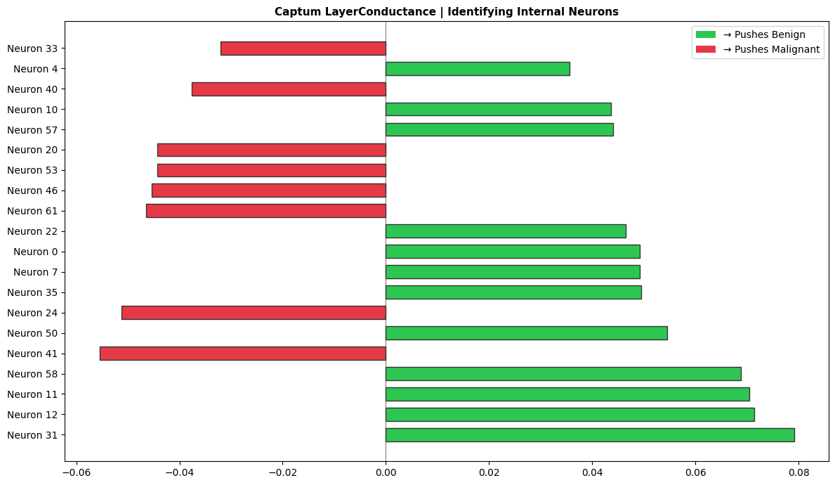

Why Performance is Considered Good
The system demonstrates high performance because it successfully balances high diagnostic accuracy with real-time interpretability.
- High Diagnostic Accuracy: The model achieved a test accuracy of 95.61%, with high precision and recall for both malignant and benign tumors, ensuring reliable clinical predictions.
- Real-time Interpretability: The integration of Captum (DeepLIFT) reduced interpretation latency to 9.07 ms, which falls below the critical 10ms threshold required for real-time clinical workflows.
- Internal Visibility: The use of Layer Conductance allowed for a "neuron-level" audit, providing deeper insights than standard feature-importance tools.

Observations
The comparative analysis revealed significant differences between traditional and next-generation XAI frameworks:
- The Latency Gap: LIME was observed to be the slowest engine at 419.37 ms, while Captum was significantly faster, making it the superior choice for high-speed diagnostic environments.
- Consistency: There was an observed agreement (Spearman ρ) between SHAP and LIME in feature ranking, but Captum provided unique insights by leveraging the model's internal gradients.

Limitations
Despite the high performance, several limitations were noted in the study:
- Local vs. Global Trade-offs: While methods like DeepLIFT are excellent for local (individual patient) explanations, they may not always capture the full global behavior of the model across the entire dataset as effectively as SHAP.
- Feature Dependency: The explanations are highly dependent on the quality of the 30 input features; if the input data contains noise or biases, the XAI tools will accurately explain a biased decision rather than a correct one.
- Complexity for Non-Experts: While neuron-level insights (Layer Conductance) are useful for AI researchers and auditors, they may be too complex for a standard medical practitioner to interpret without a simplified interface.
10. Conclusion (Phase 2 Progress)
What has been completed
What remains for final phase
11. References
Only if new tools/papers are added

Conclusion
This research addresses the critical "Black-Box" challenge in medical AI by proposing a transition from legacy XAI methods to real-time, high-fidelity frameworks. By evaluating and comparing modern frameworks like the xAI SDK against legacy methods, this study successfully bridges the Latency Gap identified in traditional models [3] and the Innovation Gap found in post-2025 literature [2].
Aligned with Saudi Vision 2030, this project demonstrates that providing clinicians with instantaneous and traceable diagnostic insights is essential for building trust and improving patient outcomes. Ultimately, this framework ensures that AI-driven healthcare is not only accurate but also transparent, reliable, and ready for the demands of modern medical emergencies.

References
- M. T. Ribeiro, S. Singh, and C. Guestrin, " 'Why Should I Trust You?': Explaining the Predictions of Any Classifier," in Proc. 22nd ACM SIGKDD Int. Conf. Knowl. Discovery Data Mining, 2016, pp. 1135–1144.
doi: 10.1145/2939672.2939778.

- Q. Abbas, W. Jeong, and S. W. Lee, "Explainable AI in clinical decision support systems: A meta-analysis of methods, applications, and usability challenges," Healthcare, vol. 13, no. 17, p. 2154, 2025. doi: 10.3390/healthcare13172154.

- A. Sathyan, A. I. Weinberg, and K. Cohen, "Interpretable AI for bio-medical applications," Complex Eng. Syst., vol. 2, no. 4, p. 18, 2022. Available: http://dx.doi.org/10.20517/ces.2022.41

- Tjoa, E., & Guan, C. (2020). A survey on Explainable Artificial Intelligence (XAI): Toward medical XAI. IEEE Transactions on Neural Networks and Learning Systems, 32(11), 4793–4813. https://doi.org/10.1109/tnnls.2020.3027314

- Rasheed, K., Qayyum, A., Ghaly, M., Al-Fuqaha, A., Razi, A., & Qadir, J. (2022b). Explainable, trustworthy, and ethical machine learning for healthcare: A survey. Computers in Biology and Medicine, 149, 106043. https://doi.org/10.1016/j.compbiomed.2022.106043

- Chaddad, A., Peng, J., Xu, J., & Bouridane, A. (2023b). Survey of Explainable AI Techniques in Healthcare. Sensors, 23(2), 634. https://doi.org/10.3390/s23020634

- W. Wolberg, O. Mangasarian, N. Street, and W. Street. "Breast Cancer Wisconsin (Diagnostic)," UCI Machine Learning Repository, 1993. [Online]. Available: https://doi.org/10.24432/C5DW2B.

